ME341A – Heat and Mass Transfer

**EXPERIMENT 2**

**PIN FIN FORCED CONVECTION**

**Date: 23 / 01 / 2018**



Department of Mechanical Engineering

Indian Institute of Technology Kanpur

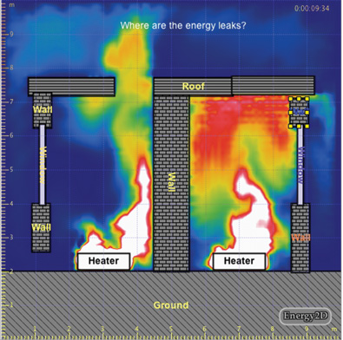

**Group – G1 (a)**

**Members:**

AVINASH KUMAR – 150169

ANUTOSH NIMESH – 150125

SHIKHAR SHIVRAJ JAISWAL – 150670

**OBJECTIVE:**

1. To obtain the variation of temperature along the length of pin fin under forced convection from experiment
2. To determine the value of heat transfer coefficient under forced convection from the experiment.
3. To evaluate:

a. Theoretical values of temperature along the length of the fin.

b. Effectiveness and efficiency of the fin.

**EXPERIMENTAL PROCEDURE:**

1. Connect the equipment to electric power supply.
2. Keep the thermocouple selector switch to zero position.
3. Switch on the blower.
4. Turn the dimmer stat knob clockwise and adjust the power input to the heater to the desired value.
5. Allow the unit to stabilize; approximate waiting time is 40-50 minutes.
6. Turn the thermocouple selector clockwise and note down the temperature T1 to T6.
7. Note down the difference in the level of the manometer.
8. Repeat the experiment for different power input to the heater.

**RESULTS AND OBSERVATIONS:**

Case 1:

Power = 35W

Pressure drop (h) = 6.2 cm

|  |  |  |  |  |  |  |  |
| --- | --- | --- | --- | --- | --- | --- | --- |
| Temperature measurement (till steady state) | | | | | | | |
| S.N | T1 (ºC) | T2 (ºC) | T3 (ºC) | T4 (ºC) | T5 (ºC) | T6 (ºC) | Time (min.) |
| 1. | 83 | 71 | 64 | 59 | 57 | 22 | 0 |

Case 2:

Power = 40W

Pressure drop (h) = 6.4 cm

|  |  |  |  |  |  |  |  |
| --- | --- | --- | --- | --- | --- | --- | --- |
| Temperature measurement (till steady state) | | | | | | | |
| S.N | T1 (ºC) | T2 (ºC) | T3 (ºC) | T4 (ºC) | T5 (ºC) | T6 (ºC) | Time (min.) |
| 1. | 83 | 71 | 64 | 59 | 57 | 22 | 0 |
| 2. | 88 | 75 | 67 | 62 | 59 | 23 | 10 |
| 3. | 90 | 77 | 69 | 64 | 60 | 23 | 20 |
| 4. | 91 | 78 | 70 | 65 | 61 | 23 | 30 |
| 5. | 92 | 78 | 71 | 65 | 62 | 23 | 40 |
| 6. | 92 | 79 | 71 | 65 | 62 | 23 | 50 |

**DISCUSSIONS AND CONCLUSIONS:**

The magnitude of the temperature gradient decreases with increasing x, which is in perfect consonance with the theory, as the amount of heat being conducted through the rod decreases with increasing x due to dissipation from forced convection. As thermal conductivity and cross section area remains constant throughout the rod, hence temperature gradient is bound to decrease.

The difference in the theoretical and experimental value of temperature can be attributed to various sources of errors which might have crept in like imperfect insulation at rod end, thermocouple not calibrated properly, material of fin is not uniform, etc. Also the experiment shows that the fin is ~60% ideal and not even closer to complete ideal nature which may also be considered as one of the reason of deviation of experimental values from the theoretical ones.

**APPENDIX:**

Length of the fin L= 150mm

Diameter of the fin (D) = 12mm

Thermal conductivity of the fin material (brass) = 110 W/m-K

Diameter of the orifice (d0) = 20

Width of the duct W = 15 cm

Breadth of the duct B = 10 cm

Coefficient of discharge of the orifice = 0.85

Density of manometric fluid water = 1000 Kg/m3

***Sample Calculation for Case 1*:**

Rate of heating, 𝑞 =35 𝑊

i. Average surface temperature of fin is given by Ts = (T1+ T2 + T3 + T4 + T5)/5 = 66.6 oC

T6 = ambient temperature = 22 oC

Tm = mean temperature = (Ts + T6)/2 = 44.4oC

ii. Properties of air are evaluated at Tm (317.5K):

a.Kinematic viscosity (v) = 17.65*10-6 m2/s

b.Prandtl no.(Pr) = 0.7045

c.Thermal conductivity of air (Ka) = 27.6*10-3 W/m-K

***Note***: Values obtained through linear interpolation of the properties specified at temperature range 300-350K.

iii. Velocity at orifice (Vo) = Cd*(1-β4)-0.5

Where β = 0.52

Coefficient of discharge (C) = 0.85

Density of manometric fluid (ρw) = 1000 Kg/m3

Density of air(ρa) = 1.16 Kg/m3

 Vo = 28.45 m/s

iv. Velocity of air in the duct ( V) = (Velocity at orifice)*(Cross-sectional area of orifice)

(Cross-sectional area of duct)

do2

Where do is the diameter of orifice = 0.02m

W = width of the duct = 0.15m

B = Breadth of the duct = 0.1m

 Va = 0.5959 m/s

v. Nusselt no. (Nu) = C Ren.Pr1/3

 where h is heat transfer coefficient.

Reynolds number (Re) = 

C is a constant and n is index values, which are given in table below for different ranges of Reynolds number.

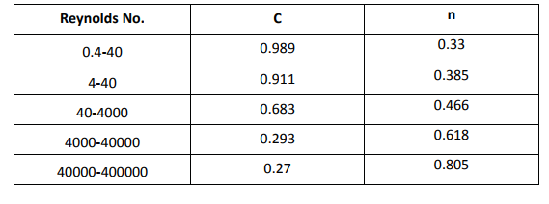

D = 12mm

 Re = (0.012*0.5959)/(17.65*10-6)

 Re = 405.144

 C = 0.683, n = 0.466, kf = Ka = 27.6*10-3 W/m-K and Pr = 0.7045

Nu = = C Ren.Pr1/3 = 10.0

 h = ( 27.6*10-3 *0.683*(405.144)0.466(0.7045)1/3)/ 0.012 = 22.94 W/m2-K

Now,

 ; K = 110 W/m-K

  m = 

 m = 8.34 m-1

Now,



 T2 = T(x=7cm) = 

 T2 = T(x=7cm) = 71.5ºC

Similarly we can find values of temperature at x=10.5, 14.5 and 18 cm i.e. T3, T4 and T5 respectively (for Heat input=35W).

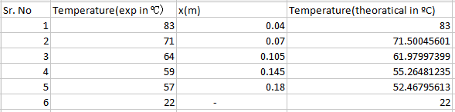

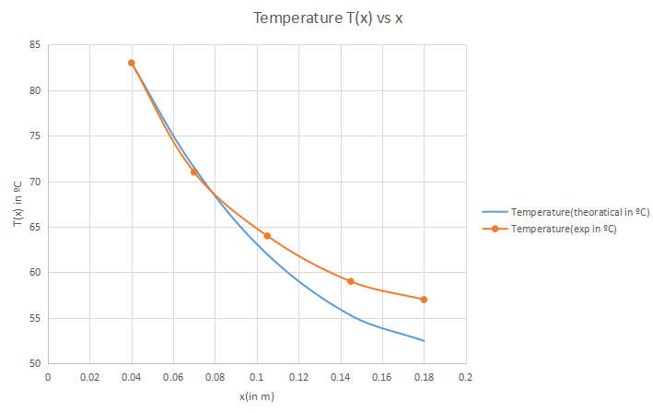

Fin effectiveness:

  = 37.228

Fin efficiency:

   = 0.5584 or 55.84%

***Sample Calculation for Case 2:***

Rate of heating, 𝑞 = 40 𝑊

i. Average surface temperature of fin is given by Ts = (T1+ T2 + T3 + T4 + T5)/5 = 73.8 oC

T6 = ambient temperature = 23 oC

Tm = mean temperature = (Ts + T6)/2 = 48.4 oC

ii. Properties of air are evaluated at Tm (321.5K):

a.Kinematic viscosity (v) = 17.96*10-6 m2/s

b.Prandtl no.(Pr) = 0.7045

c.Thermal conductivity of air (Ka) = 27.8*10-3 W/m-K

***Note***: Values obtained through linear interpolation of the properties specified at temperature

range 300-350K.

iii. Velocity at orifice

(Vo) = 

Where β = 0.52

Coefficient of discharge (Cd) = 0.85

Density of manometric fluid (ρw) = 1000 Kg/m3

Density of air(ρa) = 1.15 Kg/m3

Vo = 29.15 m/s

iv. Velocity of air in duct ( V) = (Velocity at orifice)*(Cross-sectional area of orifice)

(Cross-sectional area of duct)



Va **=** 0.61 m/s

v. Nusselt no. (Nu) = C Ren.Pr1/3

*Nu* = *hD/kf ,*where h is heat transfer coefficient.

Reynolds number (Re) =D Va / v

C is a constant and n is index values, which are given in table below for different ranges of Reynolds number.

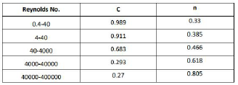

Re = (0.012*0.61)/(17.96*10-6) = 408.175

C = 0.683, n = 0.466, kf = Ka = 27.8*10-3 W/m-K and Pr = 0.7045

Nu = *h D / kf* = C Ren.Pr1/3 = 10.008

h = ( 27.8*10-3 *0.683*(408.175)0.466(0.7045)1/3)/ 0.012 = 23.18 W/m2K

Now,

 ; K = 110 W/m-K

  m = 

m = 8.382 m-1

now,



 T2 = T(x=7cm) = 

T2 = T(x=7cm) = 78.9923 oC

Similarly we can find values of temperature at x=10.5, 14.5 and 18 cm i.e. T3, T4 and

T5 respectively (for Heat input=40 W).

|  |  |  |  |
| --- | --- | --- | --- |
| **Sr. No** | **Temperature(exp in ºC)** | **x(m)** | **Temperature(theoratical in ºC)** |
| 1 | 92 | 0.04 | 92 |
| 2 | 79 | 0.07 | 78.9923191 |
| 3 | 71 | 0.105 | 68.22324927 |
| 4 | 65 | 0.145 | 60.62741069 |
| 5 | 62 | 0.18 | 57.46375366 |
| 6 | 23 | - | 23 |

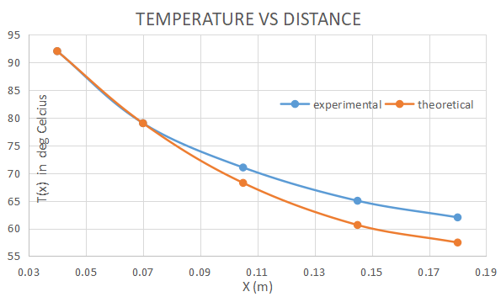

Fin effectiveness:

  = 37.078

Efficiency:

   = 0.55617 or 55.617%

**PRECAUTIONS:**

1. Switch on the blower before turning on the heater.
2. When the experiment is complete, first turn off the heater then some time turn off the blower.
3. Do not stop the blower in between the testing period.

**REFERENCES:**

1) Cengel, Y.A., Heat transfer a practical approach, McGraw Hill publication.

2) Heat and Mass Transfer lab manual

3) Sukhatme, Dr. S.P., A textbook of Heat Transfer, Universities Press

4) Holman, J.P., Heat transfer, McGraw Hill publication

5) Incropera, F.P., and Dewitt, D. P., Fundamentals of Heat and Mass Transfer, John Wiley & Sons, Inc.

6) https://www.engineeringtoolbox.com/air-properties-d_156.html

